**eWay User Guide**

Following steps will help you use eWay Payment/Clearing method on uStore.

1. Log in to uStore, select a product and proceed to Checkout.

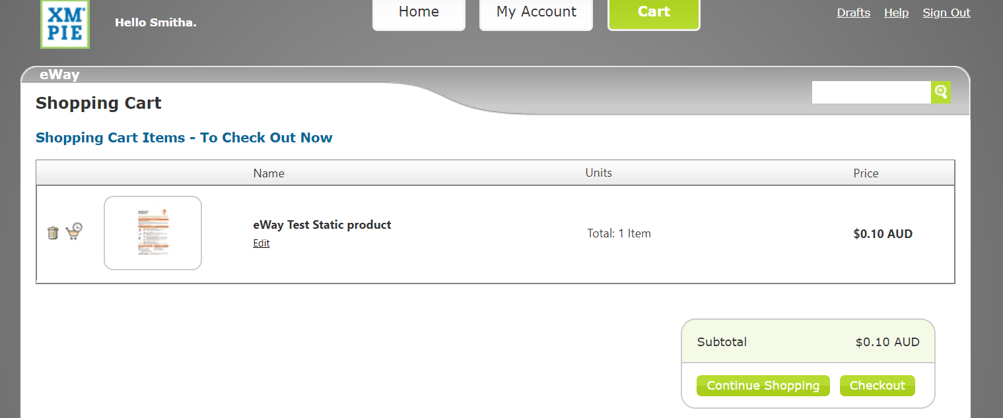

1. On “checkout” click, you will be taken to checkout order summary page. Click “Next”.

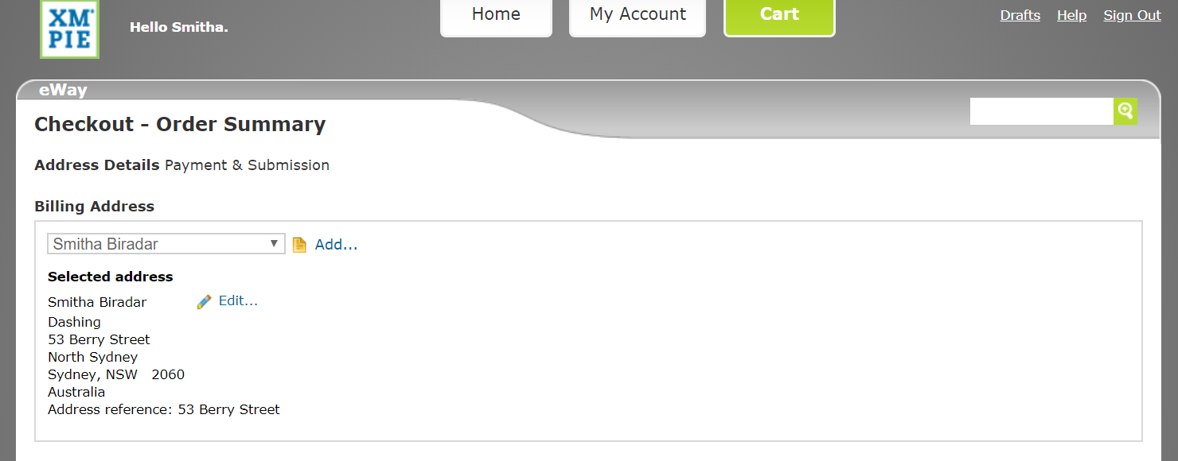

1. On Checkout Summary page, payment method options are listed under “Select Payment Method” section. Select “eWay” and click “Checkout”.

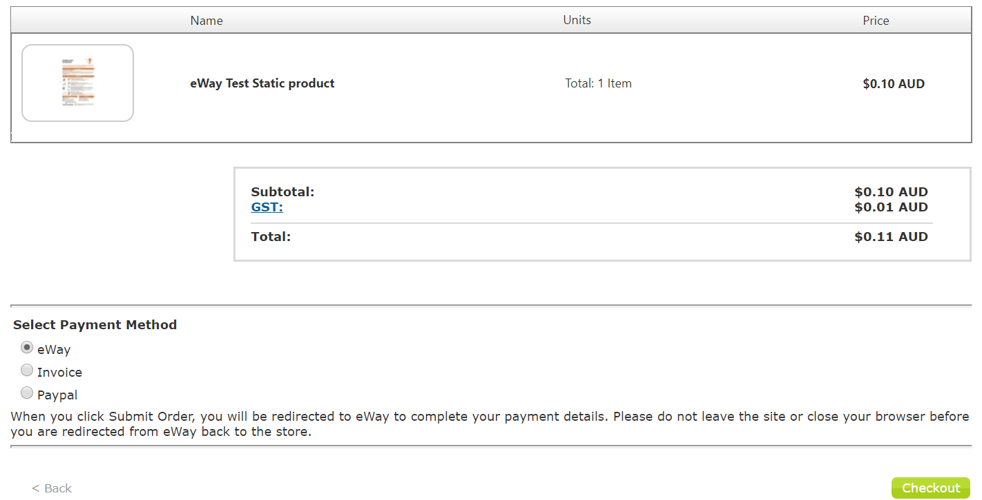

1. On Checkout, you will be taken to eWay Payment gateway page. Enter your credit card details and click “Pay Now”

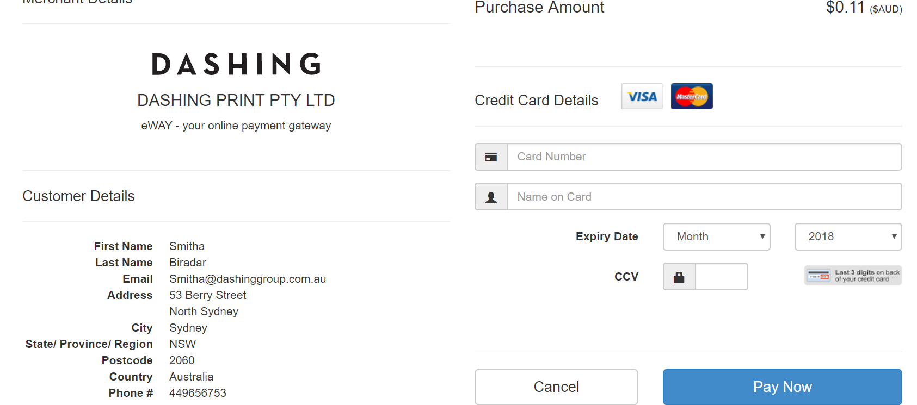

1. If you enter correct credit card details and click “Pay Now” you will be taken to Order Summary page with a success message

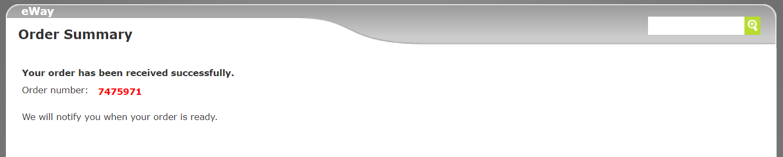

1. On Successful payment, you should receive a “transaction approved” receipt via email.

